Board | Vul | Contract | Lead | Tricks | Score |  | IMPS
 |  |  |  |  | NS | EW | H | V
17 | -
18 | NS
19 | EW
20 | All
 |  |  |  |  |  | Sum
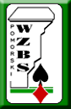

Mistrzostwa Teamów - 2013

Mistrzostwa Teamów - 2013

Board | Vul | Contract | Lead | Tricks | Score |  | IMPS
 |  |  |  |  | NS | EW | H | V
25 | EW
26 | All
27 | -
28 | NS
 |  |  |  |  |  | Sum
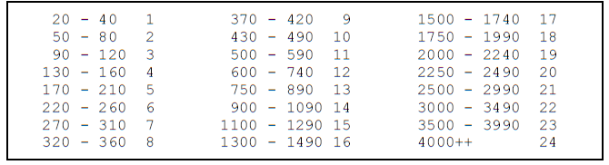
Board | Vul | Contract | Lead | Tricks | Score |  | IMPS
 |  |  |  |  | NS | EW | H | V
1 | -
2 | NS
3 | EW
4 | All
 |  |  |  |  |  | Sum

Board | Vul | Contract | Lead | Tricks | Score |  | IMPS
 |  |  |  |  | NS | EW | H | V
21 | NS
22 | EW
23 | All
24 | -
 |  |  |  |  |  | Sum

