Board | Vul | Contract | Lead | Tricks | Score |  | IMPS
 |  |  |  |  | NS | EW | H | V
1 | -
2 | NS
3 | EW
4 | All
 |  |  |  |  |  | Sum

STAISIKÓWKA - 2013

Board | Vul | Contract | Lead | Tricks | Score |  | IMPS
 |  |  |  |  | NS | EW | H | V
9 | EW
10 | All
11 | -
12 | NS
 |  |  |  |  |  | Sum
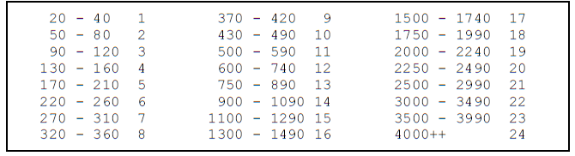
Board | Vul | Contract | Lead | Tricks | Score |  | IMPS
 |  |  |  |  | NS | EW | H | V
13 | All
14 | -
15 | NS
16 | EW
 |  |  |  |  |  | Sum

Board | Vul | Contract | Lead | Tricks | Score |  | IMPS
 |  |  |  |  | NS | EW | H | V
5 | NS
6 | EW
7 | All
8 | -
 |  |  |  |  |  | Sum

STASIKÓWKA - 2013

