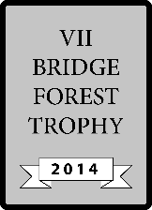
ROUND:
TABLE:
ROUND:
TABLE:

VII Forest Trophy - 2014

VII Forest Trophy - 2014
Board | Vul | Contract | Lead | Tricks | Score |  | IMPS
 |  |  |  |  | NS | EW | H | V
21 | NS
22 | EW
23 | All
24 | -
25 | EW
26 | All
27 | -
28 | NS
29 | All
30 | -
 |  |  |  |  |  | Sum
Board | Vul | Contract | Lead | Tricks | Score |  | IMPS
 |  |  |  |  | NS | EW | H | V
21 | NS
22 | EW
23 | All
24 | -
25 | EW
26 | All
27 | -
28 | NS
29 | All
30 | -
 |  |  |  |  |  | Sum

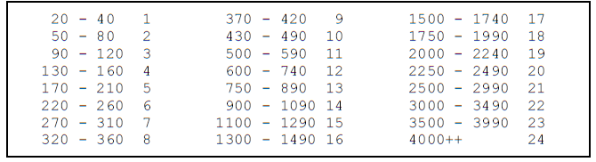
1111
OPPONENTS
OPPONENTS

