TABLE:
ROUND:
ROUND:
TABLE:

EUC Warsaw 2015

EUC Warsaw 2015
Board | Vul | Contract | Lead | Tricks | Score |  | IMPS
 |  |  |  |  | NS | EW | H | V
1 | -
2 | NS
3 | EW
4 | All
5 | NS
6 | EW
7 | All
8 | -
9 | EW
10 | All
 |  |  |  |  |  | Sum
Board | Vul | Contract | Lead | Tricks | Score |  | IMPS
 |  |  |  |  | NS | EW | H | V
11 | -
12 | NS
13 | All
14 | -
15 | NS
16 | EW
17 | -
18 | NS
19 | EW
20 | All
 |  |  |  |  |  | Sum
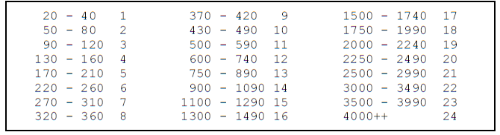
OPPONENTS
OPPONENTS

