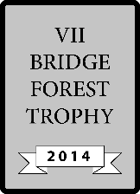
TABLE:
ROUND:
ROUND:
TABLE:

VII Forest Trophy - 2014

VII Forest Trophy - 2014
Board | Vul | Contract | Lead | Tricks | Score |  | IMPS
 |  |  |  |  | NS | EW | H | V
1 | -
2 | NS
3 | EW
4 | All
5 | NS
6 | EW
7 | All
8 | -
9 | EW
10 | All
 |  |  |  |  |  | Sum
Board | Vul | Contract | Lead | Tricks | Score |  | IMPS
 |  |  |  |  | NS | EW | H | V
1 | -
2 | NS
3 | EW
4 | All
5 | NS
6 | EW
7 | All
8 | -
9 | EW
10 | All
 |  |  |  |  |  | Sum
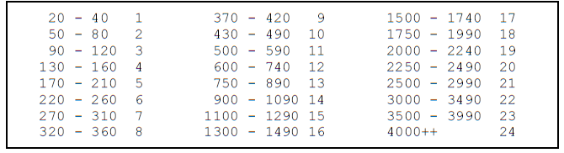
OPPONENTS
OPPONENTS

